Date: 2016.10.14

ASR 6372

**From:** Ong, Peh Lee   
**Sent:** Tuesday, 11 October, 2016 2:07 PM  
**To:** Chan, Pei-Fong  
**Subject:** [REQUEST] Inbound Dashboard - Current Utilization Rate_By Storage Type

Dear Pei Fong

Can we request to update the utilization rate from CAT85 to CAT95 due to KPI change?

Meaning utilization rate above 95% will only display in red color.

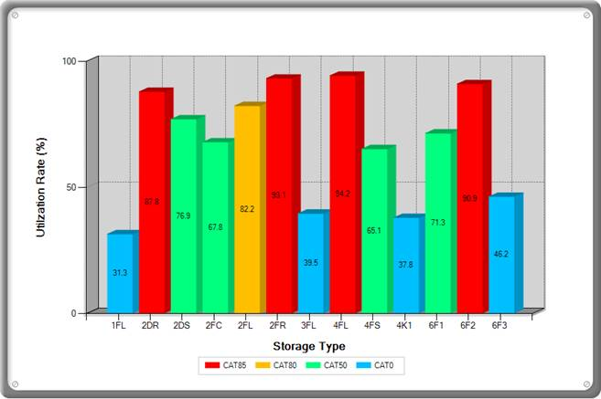

Many Thanks

Ong Peh Lee (Ms)

Warehouse Planner

Contract Logistics/SCM